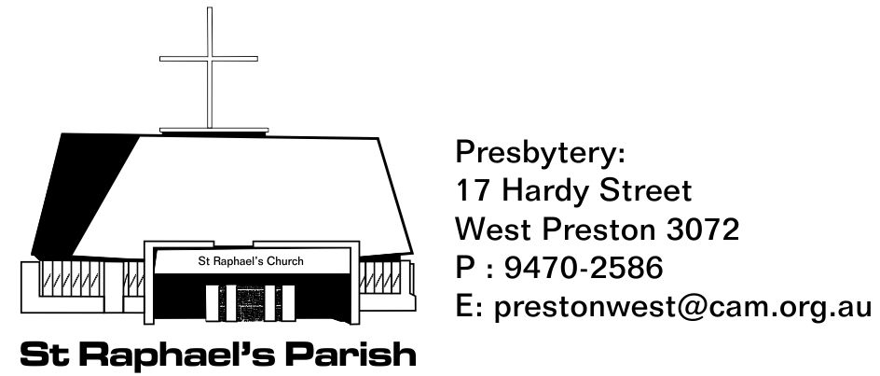
SACRAMENTAL PROGRAM ENROLMENT FOR
FIRST RECONCILATION, FIRST EUCHARIST AND CONFIRMATION
Please complete this form in block letters. Please fill out a separate form for each child.
Child’s Surname: ___________________ Christian Names: ________________________ Date of Birth_____________
Postal Address: __________________________________________________________________Post Code:__________
Phone Numbers: (Home) _________________________ (Mobile) _________________________
Email: __________________________________________________________________________
Child’s Grade: ________________
Father’s Full Name: _____________________________________________________
Mother’s Full Maiden Name: ______________________________________________
Please enter below details of the Sacraments your child has received and tick the box for the one(s) to be received. In this Parish, First Reconciliation is received prior to First Eucharist and usually takes place during the same year. If you have any queries regarding your child’s readiness to receive the Sacraments, please contact Fr Simon at the Parish Office.
- Baptism Date & place received: ___________________________________________(Copy attached)
- First Reconciliation Date & place received: _____________________________________________(if applicable)
- First Eucharist Date & place received: _____________________________________________(if applicable)
- Confirmation Sponsor’s* Full Name: _____________________________________________(if applicable)
*The Sponsor must be a practicing Catholic (preferably the child’s Godparent) and cannot be the child’s parent.

Please note that it is customary in most parishes to give a donation of $35 minimum to the Parish for taking part in the Sacramental Program.
Donation amount:____________ Payment Method (please circle): Cash / Cheque** / EFT#
** Please make cheques payable to: St Raphael’s Parish West Preston Presbytery account.
# National Bank Melbourne
St Raphael's Parish West Preston Presbytery account Date Deposited:__________________
BSB: 083 347, Account Number: 643967856 (Please use Child’s Name as description)
Please return this form, payment and copy of your child’s baptism certificate to the Parish Office or to St Raphael’s School marked for the attention of Fr Simon.

