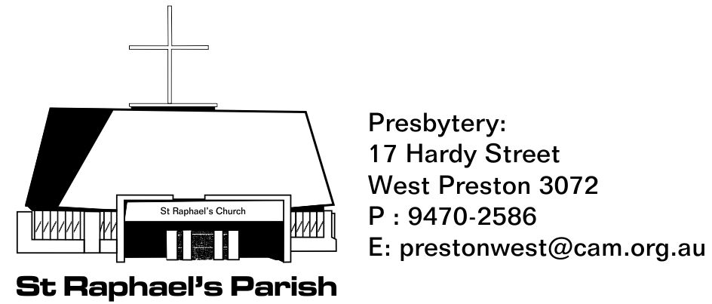
REQUIREMENTS FOR BAPTISM
Dear Parents,

Please find enclosed a “Request for Baptism of an Infant” Form, for you to complete, and return to St. Raphael's Parish, at the address given above or via email.

Baptisms are celebrated at St. Raphael's Parish church, after the 10:30am Mass at 11:30am and 11:45am. The Celebration of Baptism will take around 15 minutes. These are set times, so please be punctual.

Once I receive your completed form I will give you a call and arrange a day and time for me to meet with you and your family. The meeting will take around 30 minutes at your home or at the above address.

One or two weekends before the Baptism, it is a requirement for you and your child (and other family and friends if you wish), to attend a weekend Mass to be welcomed by the parish of St Raphael’s.
Masses: Saturday (vigil) 6:00pm, Sunday 9:00am (Italian) and Sunday 10:30am
Please advise which day and Mass you will attend so that the parish bulletin can be noted accordingly.

A fee to the church of $100 per child to cover expenses is greatly appreciated. Please provide this before the Baptism takes place. You may pay this directly to our church account or you may give it to me in an envelope at our meeting or at the welcoming Mass.
Godparents/Sponsors: only one Godparent/Sponsor is required but must be 16 years or older, be baptised Catholic, Confirmed, received the most holy sacrament of the Eucharist and who leads a life of faith in keeping with the function to be taken on (Canon Law c.874). The Godparent/Sponsor can be male or female or one of each but not two of the same (c. 873). You may include a Christian Witness (from other Trinitarian Christian traditions) in addition to the catholic Godparent/Sponsor (c.874 §2).

In the case of parents wishing to have their child baptised at St Raphael's, but are residing in another parish, a written approval from the parish priest of the other parish must be presented with the Baptismal Form. Church Law states that after six months that a Catholic has taken up residence, the parish in that territory becomes his parish; so a written approval from the parish priest is needed.

On the day of Baptism, please bring with you a Baptismal candle for your child (and a baptismal stole if your child is not wearing a white garment).
A Certificate of Baptism will be given to you after the celebration of Baptism.

Looking forward to meeting you both,
Yours in Christ,

Fr Simon Grainger
Parish Priest

Request for Baptism of an Infant
To confirm your booking, please complete and return this form along with your donation to the parish office.
our child
Christian name: |  |  | Family name: |  | Date of birth:  Place of Birth:
Family details
Address*:
Contact telephone: |  |  |  |  | Parish*:
Email:
Father’s Christian name: |  |  | Family name: |  | Religion:
Mother’s Christian name: |  |  | Maiden name: ** |  | Religion:
Date and place of marriage (if applicable):
Child’s siblings | Name: |  |  |  | Date of birth:
 | Name: |  |  |  | Date of birth:
 | Name: |  |  |  | Date of birth:
Godparents | Godparent: |  |  |  | Religion:
 | Godparent or witness: |  |  |  | Religion:
Proposed dates
Preparation: |  | Welcome: |  |  |  | Baptism:
Certificate:
Record of preparation
Program date & time:
Program facilitator: |  |  |  | Priest:

* If residing outside this Parish, you must obtain a letter of permission from your local Parish Priest prior to your child’s Baptism. Circle one: permission attached/permission requested
** It is Church requirement that the Mother’s maiden name is written in the Baptism register.
.

Parents declaration
We request that our child...................................................... receive the Sacrament of Baptism. We personally believe all that Christ has taught us, and we are dedicated to the Christian way of life and wish to pass on to our children the joy of this faith. We understand that Almighty God holds us responsible for the Catholic upbringing of our baptised child. We acknowledge that the child’s first school is the home, and in our home we shall endeavour to provide an example of true Catholic living. In particular, we acknowledge our duty to promote family prayer and to attend to Sunday Mass. We are also aware that our child must be prepared carefully for the Sacraments of Reconciliation, Communion and Confirmation. We understand what is expected of us in giving this infant child a continuing education in the riches of our Catholic faith.
We pray to God for His grace to aid us in carrying out our duties as parents.
Signed.............................................................. ..............................................................
Father Mother

Please note that there is a church fee of $100 per child to cover expenses for the Baptism.
Please provide this either by cash or paying this directly to our account below
Please contact Fr Simon if you are not in a position to pay this fee.

Donation amount: $………………… Payment Method: Cash / EFT#
# National Australia Bank Melbourne,
Account Name: St Raphael’s Parish West Preston Presbytery account
BSB: 083 347
Account Number: 643967856
Reference: your surname and 'Baptism'

Kindly email the receipt to: prestonwest@cam.org.au

