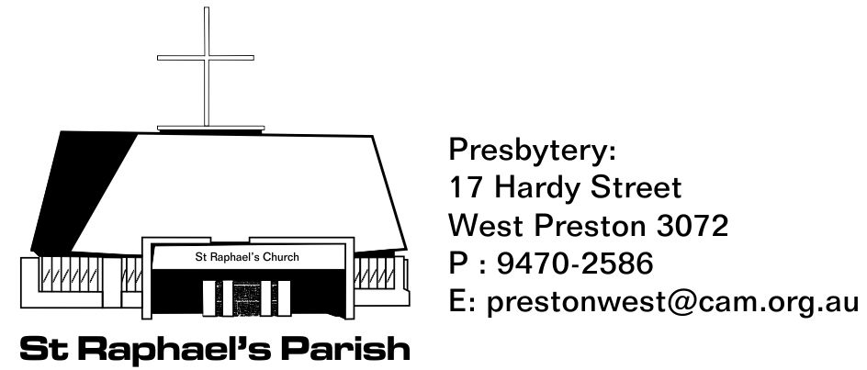
MARRIAGE APPLICATION FORM – Please complete and return to the Parish Office:
GROOM: | BRIDE:
Surname: | Surname:
Christian Names: | Christian Names:
Address: | Address:
Telephone: Work:  Home:  Mobile:  Email: | Telephone: Work:  Home:  Mobile:  Email:
Occupation: | Occupation:
Religion: | Religion:
Marital Status: | Marital Status:
Date of Birth: | Date of Birth:
Place of Birth: | Place of Birth:

Date of Marriage:……………………………………………………Time:…………………..
Place of Marriage:……………………………………………………………………………...
Celebrant’s name:………………………………………………..Phone no.:……………….

Documents required: For celebrating priest: Birth certificate or passport, Baptism certificate, Confirmation details Permission/Freedom to Marry letter (when marriage takes place outside Parish of residence).
Marriage offering to Priest: $300.
Fee for use of Church (if applicable): $300 (payable prior to the date of marriage). This fee does not include flowers or organist’s fee.

